Instructions and template for extended abstracts
Simon Löw^{1*}, Matthew Perras¹, Martin Ziegler¹ and Kerry Leith¹
¹ Department of Earth Sciences, ETH Zurich, Switzerland
* simon.loew@erdw.ethz.ch

Deadline
The extended abstract submission deadline is January 27th 2017.

Language
Abstracts should be submitted in American English.

Extended abstract size and naming convention
Your abstract should not exceed 2–4 pages in the format shown here including optional figures, captions and references. Please make sure that the file names are in the following form: surname_name (e.g. Albert Einstein: einstein_albert.doc, einstein_albert.pdf.). Please leave the abstract number empty.

Title and authors
For the title please capitalize the first word and Names only and list authors by order of contribution to the extended abstract with "Full_first_name_author1 Surname_author1", Full_first_name_author2 Surname_author2", etc…. For each author please indicate Institution and the e-mail address of the main author.

Pre-defined text styles and further instructions

Pre-defined text styles
Please use the predefined styles (Table 1).
Table 1. Predefined styles
Text element | Pre-defined Style
Abstract title | use «Title»
Addresses of authors | use «Address»
Authors | use «Authors»
Body text | use «Body text»
Bullet lists | use «Bullets»
Figure and table captions | use «Figure caption» and «Table caption»
Reference list | use «Reference list»
Section headers | use «Section header» and «Sub-header»
Table text | use «Table text»

Further instructions
Use Arial 11, 1.15 spacing, italics and scientific notations according to standard international rules. Margins are given by this template. The abstract file should be submitted in .doc or .docx (or .rtf) format. In addition, we request the submission of a .pdf file to enable us to check for correct reproduction of special characters. Use automatic hyphenation.

Figures, photographs and tables
We recommend to submit drawings and photographs in pixel form (e.g. .tif, highest quality .jpg). Please make sure that you scale your illustration to printing size (maximum 24 cm x 17 cm). Please check that your figures and included text are readable at this size (avoid text smaller than 8pts). We recommend a resolution of 600 dpi for pictures and graphics. Mention the name of the photographer or the source in the caption. Please put captions directly below figures and photographs (see below) and above tables. Please include all texts and annotations in the figures themselves. DO NOT add texts or annotations over the figures in your text editor. For tables stick to the illustrated format.
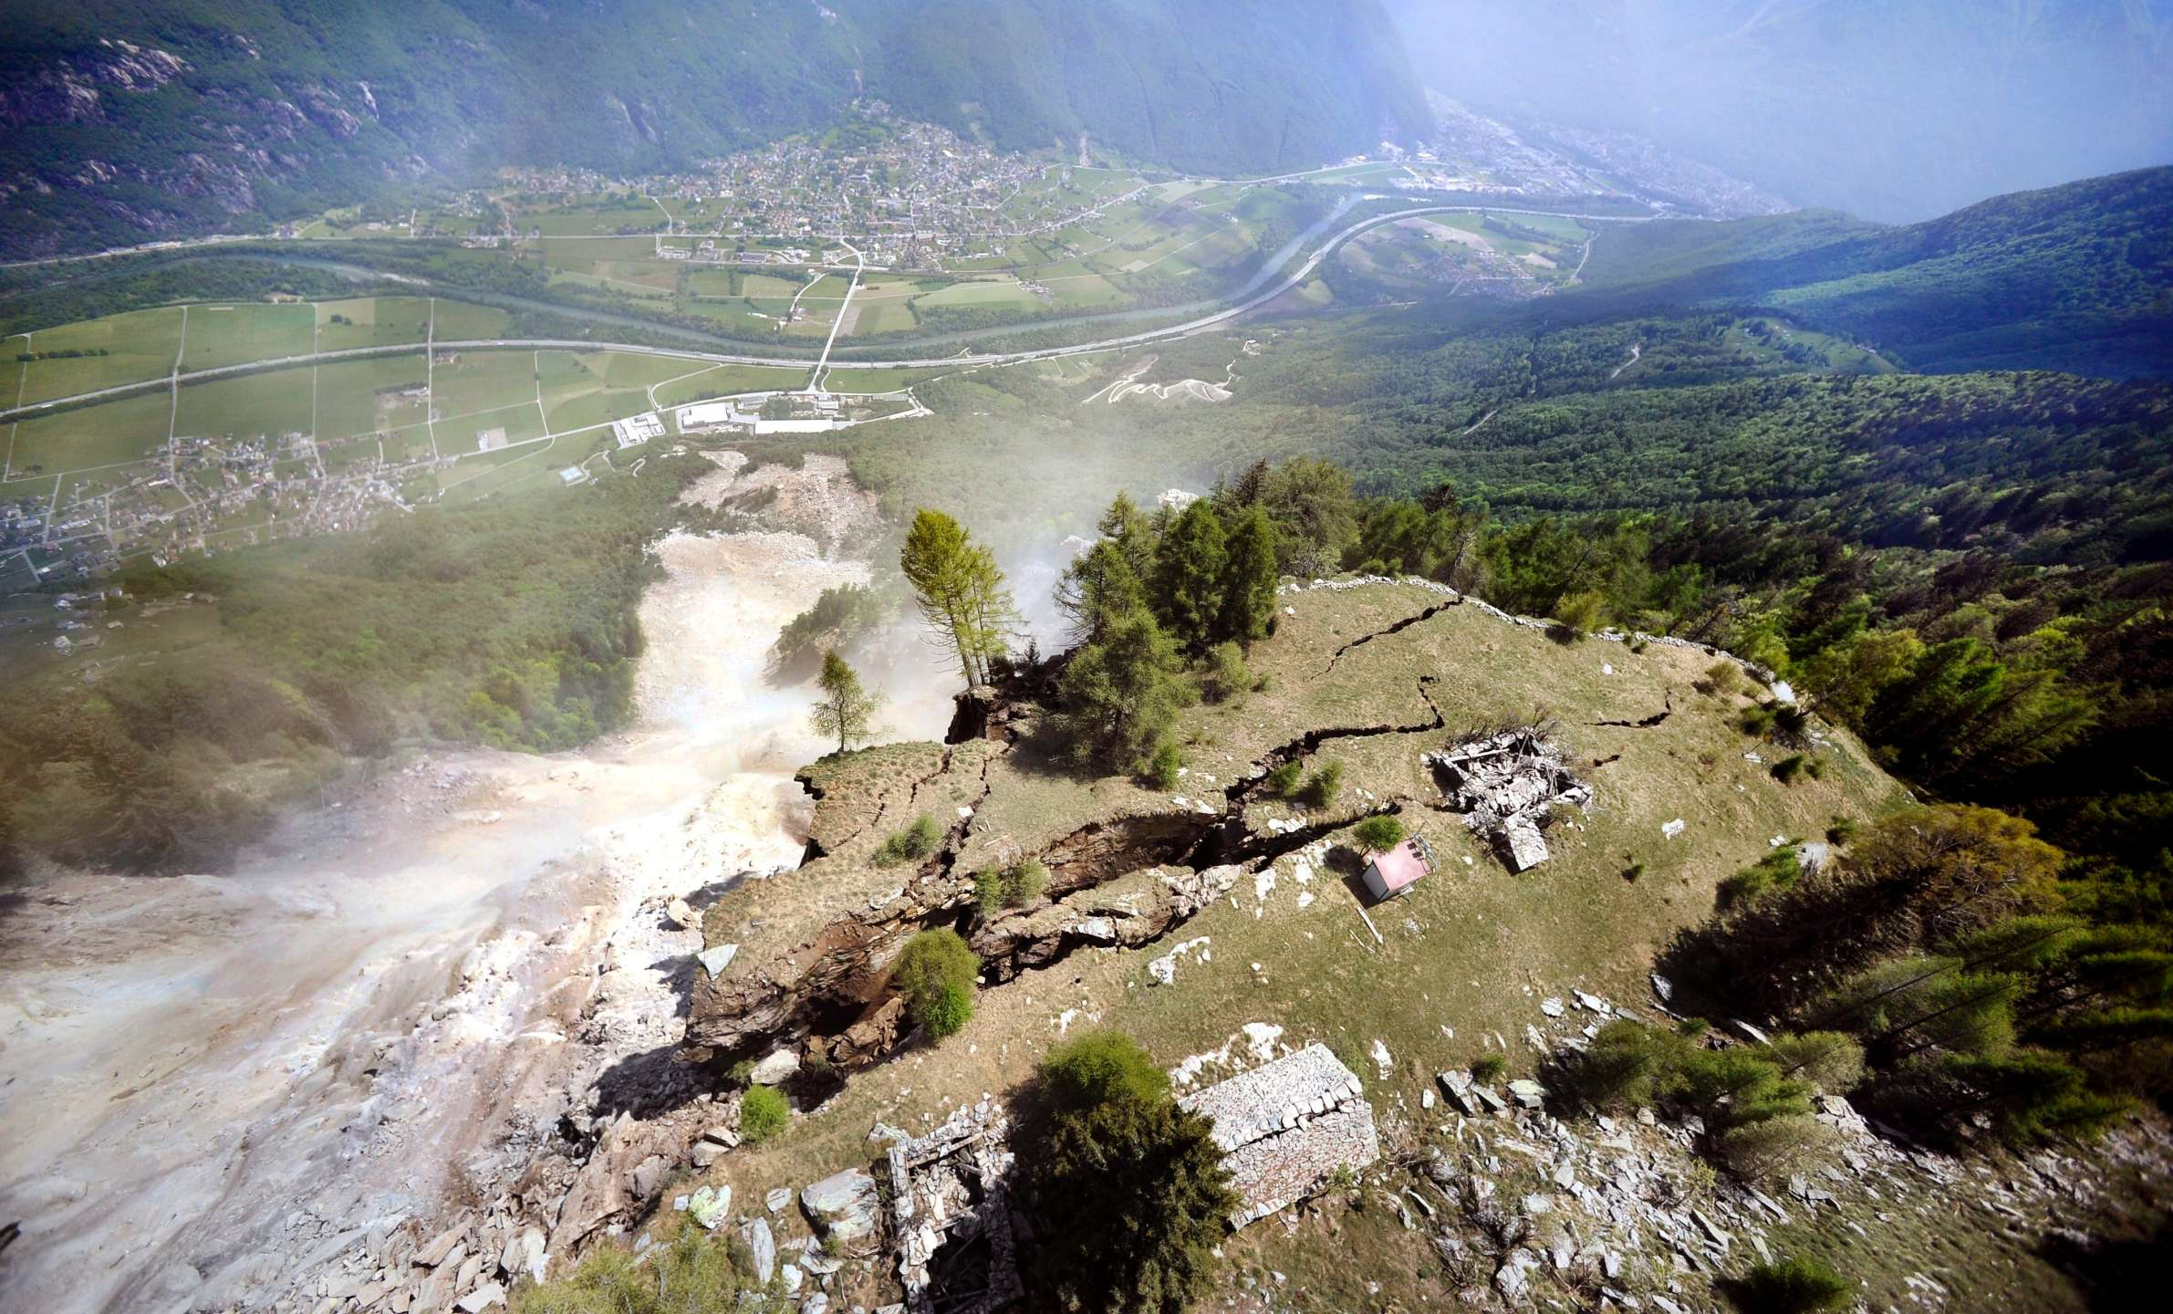
Figure 1. Photograph of the Preonzo instability complex situated above the village of Preonzo in the Rivera valley of southern Switzerland (Canton Ticino) (photograph ©Ti-Press/Carlo Reguzzi).

References
Please put references at the end of the extended abstract text. References should be cited in the text as follows:
- Author & Author (1989) instead of Author and Author (1989)
- (Author 1989a, b; Author & Author 1987) instead of (Author, 1989a,b; Author and Author, 1987)
- (Author et al. 1989) instead of (Author, Author & Author 1989)
- Use the following style: (Author, in press); (Author, in prep.); (Author, unpubl.); (Author, pers. comm.)

Reference list
Jappelli, R, Marconi, N. 1997. Recommendations and prejudices in the realm of foundation engineering in Italy: A historical review. In Carlo Viggiani (ed.), Geotechnical engineering for the preservation of monuments and historical sites. Proc Int Symp, Napoli, 3–4 October 1996. Rotterdam: Balkema.
Terzaghi, K, Peck, RB. 1987. Soil mechanics in engineering practice, 2nd ed., McGraw Hill, New York, NY, USA.
Terzaghi, RD. 1965. Sources of error in joint surveys. Geotechnique 15, 287–304.
Vijaykumar, S, Curran, JH, Yacoub, TE. 2001. Node-centric displacement discontinuity method for plane elasticity problems. In Desai et al. (eds.), Computer Methods and Advances in Geomechanics. Proc 10th Int Conf, Tucson, 7–12 January 2001. Rotterdam: Balkema.

